SWINDLERS OF THE BEAT

An Opening Cutscene

Written and Compiled by Gabriel Ling

Special Thanks to Prof. Angie Hoffman

A quick note: for each dialogue option, the player is given a set amount of time to make a choice on what to say. If the timer runs out, a default choice is automatically picked. These choices are underlined in the script.

**Opening Cutscene:**

INT. Musty motel room – evening

A yellowed slip of fire safety information crudely taped to a mechanical door jumps and shakes as loud banging and yelling noises sound from the hallway beyond. Dust falls from the ceiling with every bang. Suddenly, the door itself rattles violently against its frame once, twice, before sliding open with a crunch as CATNIP and QUINN DASSIAN tumble into the room and onto the floor.

CATNIP

Aha! Got it!

Catnip is a young, ambiguously gendered human with olive skin and a poofy tuft of dark brown hair. They are dressed in a heavy cloak with a high collar that covers a lot of their lower face.

They gracefully roll to their feet, deftly brandishing a silver card. Quinn viciously scrambles to lunge at them.

QUINN

You *rat*! I never should’ve trusted a deadbeat like you!

Quinn is a slightly older, greasy-looking man in well-worn pleather jacket. He’s a little larger and slower than Catnip, but could be mistaken for their relative.

Catnip dodges to the side as Quinn tumbles past.

CATNIP

A (You’re not wrong.): 🡪 I mean, yeah. Ya shouldn’t’ve.

B (I’m sorry.): 🡪 Sorry, Quinn. I’m just doin’ what I gotta do here.

C (You made it easy.): 🡪 If you didn’t wanna get robbed, try being less robbable next time.

Quinn gives a primal roar as he starts to throw things at Catnip—a lamp, a plant, etc.

Catnip ducks down behind a chair. This is where the faster-paced action choices are introduced:

A: (Dive left)

B: (Dive right)

C: (Run straight at him)

The paths look visually different (maybe one runs by the window and another runs by the door), but ultimately the result is the same: Catnip dives out from behind the chair, runs in close to Quinn and delivers a dirty uppercut to his chin. Finally, he is down and out for the count.

Catnip triumphantly holds up the card they’ve nabbed. It’s Quinn’s ID card. The photo on it looks like an older, drunker version of Catnip. They could pass for being related.

They plug it into a device of some kind, which they then hold against the back of their neck. It looks like data is being transferred into a chip located there.

The voice of GOOSE crackles through a communicator hidden near Catnip’s ear.

GOOSE

Good job, kid. Knew that dumb lug would fight just as bad as he plays.

Catnip reaches to their ear to touch the communicator as they respond.

CATNIP

Heh, yeah. Where are you?

GOOSE

Hold on, not so fast there. We don’t want the **hubble** lookin’ for us until *after* we’ve taken off. Better make sure Quinn doesn’t go raisin’ any alarms, right?

CATNIP

*(still through the communicator)*

Hmm. Alright. I’m sure I can find some way to keep him quiet for a bit.

*(to themself)*

…I should tie him up, gag him, and put him somewhere quiet. Shouldn’t be too hard.

The camera shifts to a fixed position in the room that displays all interactable objects. Many objects can be examined to provide a taste of what life looks like on Heartbeat. For example:

CATNIP

*(looking at the cityscape through a grimy window)*

Ah, the sprawl of the Beat. Only lowlifes and street rats like me hang out on the lower levels. Pricks like Quinn hang out at the midline up here. And up at the top… only **Unity Corp**. weasels grace the skies up there.

*(looking at the television)*

Nothing but ads and propaganda.

*(looking at the broken phone)*

The only person I woulda called is on my comms anyway.

After the player interacts with the curtains, the pillows, and the bed, the cutscene progresses. Catnip rips the curtain into strips to tie up Quinn. They use the pillow case to gag him, and they stash his sleeping body under the bed.

CATNIP

Another job well done.

*(through the comms)*

Quinn is taken care of. Where should I pick you up?

GOOSE

By the harbor. I’ll get ready. See ya soon, kiddo.

Catnip locks the door as they leave, and they begin to make their way to the pickup location. Their journey takes them through moist pink streets, over rusty fences, and under several neon streetlights.

EXT. Busy space harbor – evening

Thronging crowds suffocate the space of a busy space harbor. Humans and aliens of all kinds make their way through the bustle with their heads down and cloaks up. A janky-looking rustbucket of a shuttle is parked in the far corner.

Catnip stops by an unassuming alley to pick up an absurdly large instrument case.

Goose’s voice comes through the comms once again, but it also sounds vaguely muffled, from within the case.

GOOSE

Woah, take it easy there! It’s cramped in here.

Catnip affectionately thwacks the case twice before swinging it onto their back. It dwarfs their figure.

GOOSE

Goddamn kids with no goddamn respect for elders these days.

Catnip rolls their eyes as they begin to make their way to the shuttle.

Catnip approaches the gate, only to be stopped by a GUARD.

GUARD

Hold up.

CATNIP

A (What?): 🡪 Sorry, what?

B (What do you want?): 🡪 What the gunk do you want? I’m in a hurry, here.

C (Good evening!): 🡪 Good evenin’, sir!

**If the player selected A or B:**

GUARD

Hold up, citizen.

**If the player selected C:**

GUARD

Oh, uh, hello.

The guard scans the back of Catnip’s neck.

GUARD

What’s your name?

GOOSE

Don’t muck this up now, kid.

CATNIP

A (Quinn Dassian): 🡪 The name’s Quinn Dassian.

B (Flynn Dassian): 🡪 The name’s Flynn Dassian.

C (Jyn Dassian): 🡪 The name’s Jyn Dassian.

D (…): 🡪 Uh…

**If the player selected A:**

GOOSE

That’s right. Just like we practiced.

**If the player selected B, C, or D:**

GOOSE

What the—come on, kid. *Quinn Dassian.* Remember it this time. It’s too early to be making mistakes like this.

Goose will remember that.

CATNIP

Uh, Quinn! I mean, Quinn Dassian.

GUARD

Hm, I see. Headed towards **Meszon**, eh? **Dangerous times** to be heading thataways. What’s your business there?

CATNIP

A (I play music.): 🡪 I’ve got a performance comin’ up next chunk. If you like crunch, you might’ve heard of me?

B (Vacationing.): 🡪 I’m taking a chunk off to sightsee. The biolumes are in bloom, don’tcha know?

C (None of your business.): 🡪 Ain’t none’a your business, **hubble**.

GUARD

Hm.

He tries to scan Catnip again, but the same error beeping sounds.

GUARD

‘Byssal scanner isn’t working again. Stay here.

He leaves, presumably to fetch help. Other guards passively watch the onboarding gate.

CATNIP

*(furtively)*

Ah, *gunk*. Goosey. There’s something wrong with my biochip. The scrambler we got must be jank.

Catnip pulls out the handheld device from before and shakes it with frustration. They whack the scrambler against their palm a couple times.

GOOSE

What? How?

CATNIP

I don’t know, couldn’t see the screen. Give me some backup here.

GOOSE

Hahaha, like how? Ya want me to pop out of here and get us both arrested?

Catnip violently thwacks the lute case on their back.

GOOSE

Hey—ouch!

The guard returns. Catnip hides the scrambler.

GUARD

Aaaand let’s give this one a try… Citizen Quinn Dassian, right? Our systems are saying you canceled your flight about an hour ago.

CATNIP

I what now?

GOOSE

*(suddenly very cold)*

I thought I told you to leave that sucker for dead.

CATNIP

*(responding to both the Guard and Goose)*

I wouldn’t do something like that.

GUARD

Well, it says here you did, citizen. At 16:05, to be precise.

GOOSE

That slippery bastard. What did you do? He’s going to gunk this up for us. We need that money, Cat!

CATNIP

A (Who’s your manager?): 🡪 Can I speak to your manager, hubble?

B (This is ridiculous.): 🡪 Hey, I got places to be. The flight’s about to take off. Is this really necessary?

C (Can I undo that?): 🡪 …Can I uncancel it?

**If the player chose A, or B:**

GUARD

Aw come on, buddy, I'm just doin' my job here. Fine, whatever. Get out of here.

CATNIP

Fuckin’ thank you.

GOOSE

Nice one, kid.

**If the player chose C:**

GUARD

Sure, citizen, but you'll be charged double.

CATNIP

Oh, that’s fine.

GOOSE

Watch it, fancy pants, we might need those creds later.

**If the player was nice to the guard earlier:**

GUARD

You be safe now, you hear? Those **lizard folk** don’t take kindly to Beat runners like us.

**If the player was rude:**

GUARD

Now quit loiterin’ and get outta here.

Catnip nods and proceeds through the gate.

CATNIP

Stars, finally. Let's get this job underway, yeah?

END SCENE.

**Character List**

* Catnip (alias Quinn Dassian):
  + Human, age 19
  + Ambiguously gendered voice
  + Olive skin, curly dark hair cropped short but with a messy tuft on top.
  + Young, athletic, scrappy, bearing several scars.
  + Rowdy, good-natured, kind of dumb kid but with a heart of gold. Very good at lying. On another planet, maybe they would’ve grown up to be an enterprising young professional—but, on the streets of Heartbeat, they are a raggedy rapscallion out to pinch pretty pennies.
* Goose
  + Human, age 25-30
  + Male gendered voice. Scratchy, like he smokes too much
  + Sly, smart, and always on the lookout for opportunity. Has no qualms with murder, but doesn’t get his hands dirty. A messed up older brother figure for Catnip. Always ready to remind them just how much they need him around.
* Eun-ji
  + Age 20
  + Female gendered voice—though they are entering the “male” stage of their reproductive lifecycle.
  + The Celin child of the union of two very wealthy corporations, they live in the lap of luxury. Charming, benevolent, and hopelessly idealistic. They are secretly a member of a rebel organization, though they are fresh and untested, and have never seen combat.
* Dara
  + Age 200+, but voice age 55-75
  + Female gendered voice. Old, measured, wise, and reptilian—very nasal and raspy.
  + An alien posing as a bodyguard for Eun-ji, but secretly the leader of a rebel organization bent on liberating her own species. She is distrusting of Humans and Celins alike, though she likes and respects Eun-ji.
* Jayden
  + Age 35-45
  + Male gendered voice. Tired, like Morgan Freeman in Se7en.
  + Secretly an undercover cop (HBLE or “hubble”) posing as a construction materials vendor. Knows how to blend into a background and fly under the radar. Can be charming and disarming with his charisma, but can turn on a dime to reveal the cold, calculating pathology underneath the façade.

**Casting Sides**

**Catnip**:

They call me Catnip. See, I kinda gotta thing with animals. Stray cats on the Beat, people don’t treat ‘em nice. I do. I like to, anyway.

I been runnin’ with the gang for years now, long as I can remember. Goosey boy, he’s been like a big brother since I was just a little kid. Taught me how to scramble chips, and also how to hide from the hubble when they come snoopin’, and also how to smile nice and look dumb when they come askin’.

He didn’t teach me this, though. This I picked up from the players at the pub. Cost me a loootta creds to get a crunch lute this fancy. They say not just anyone can crunch—lotta Humans are too stiff for it, don’t have the flex needed. Lucky I grew up around all sorts. I’m no expert but I’m no fool neither—I can play you a little bit if you want?

Goose ‘n me put together a lil heist of sorts. I get to take the lute on this one. I’m going undercover, gonna be cozying up with some dumb bigwig from the Unity Corporation. When we scramble this chip, we’ll be richer than a pair of gas gophers in a fuel tank. When him and me are livin’ nice and large like those Unity goons, maybe I’ll finally have a bike of my own. Wouldn’t that be nice?

**Goose**:

You spend enough time on the Beat, you pick up a thing or two. People’s hearts, maybe it really is a glass half full kind of situation. But in my experience, the glass has always been half full of something rotten.

Trust me when I say this—don’t trust anyone. The cops are more trigger-lusty than a kid in an arcade. The other rats on the street know to throw a wide berth for the gang at least. But they’ll try to get in good with us. We been backstabbed too many times to make a mistake like that again. Those kinds usually end up dead. Cops would be, too, if we could.

I don’t do murder. I don’t like to, at any rate. Messy, risky business. And it could be you that ends up shuttin’ your eyes for the last time. And even if it ain’t, sure does make you think of it.

No, the killing’s best left to those who like it. I don’t quite understand it, but hey, to each their own. What’s important is that it gets done. Because I find, in most situations, it needs doing.

Picked up the scent of some rich bigwig headed to some slumber party on the Meszon Moon. They’re makin’ the mistake of getting on a private uninterrupted transport for over 28 hours later this week. All goes according to plan, Cat and I’ll be swimming in it. Damn, that gunky kid is lucky to have me.

**Eun-ji**:

My father is a Human from Earth, and my… hm, there’s not really a word in English for it. But, my other parent is a Celin from Emina. The family companies have had a presence here on Heartbeat for many years, at least two decades. But, my parents are the first in my family to actually live here.

And so I live here too. But unlike them, I *love* it. There’s so many sights and sounds, and it’s almost like I can *feel* the rhythm of the city’s people. From the 84th floor, you can see so much of the city’s expanse. I never would’ve met so many colorful characters from all kinds of backgrounds if I grew up someplace boring like the homestead. I feel privileged to have exposure to such a diverse population.

I love the people on Heartbeat. As the eventual heir to my family’s legacy, it’s my job to do my best for the people, no matter what. And I will! I think—I *know* it’s critical to be aware of everyone that could be affected by a company decision. Sometimes, it’s easy for those who don’t know hardship to forget the plights of the poor. But me, I want to keep my eyes wide open, and to do as much as I can for all parties involved. I guess that’s really my mission. Nobody should have to suffer, and profit should never necessitate suffering.

**Dara**:

My home is crumbling.

Of course, it is the fault of the Unity. \**hssss*\* 2 centuries I have laid my eggs on Meszon, and now they tell me to find a new planet. And why? So they can build more casinos and filthy clubs on the land I reared my young ones?

Before this, I was a painter. Now, there is nothing to paint but destruction. So I do not paint. Now, I lead my people. We will stop the terraforming and we will destroy the drills that ruined us. But we need help. There is a fleshy one—a Unity child—they wish to help us.

At first I did not trust them, I will be honest. But they have shown their use and proven the depth of their intent. We will take them to the drills. They will help us.

**Jayden**:

Life as an enforcer of the HBLE is not easy. It’s not *fun* work, nobody *likes* risking their lives. But sometimes I get a kick out of it. Mostly when some rat thinks they’re outsmarting me. That’s when it becomes almost like a game.

Unity, Mezson, Humans, Celins, it’s all gunk when it comes down to it. None of it really *matters*. Some win, some lose, the whole thing gets repeated a few lightyears away. Big deal. I just try to stay on top of it all.

My latest assignment is the most fun I’ve had in a while. Turns out the Unity kid’s run traitor. I’ve been advised not to use lethal force, obviously. But wouldn’t it be a shame if something bad happened?

**Reference Images**

Setting:

Heartbeat:

<https://twitter.com/steveroe_/status/983282178627813376>

<https://www.artstation.com/artwork/oPk2J>

<https://www.beeple-crap.com/>

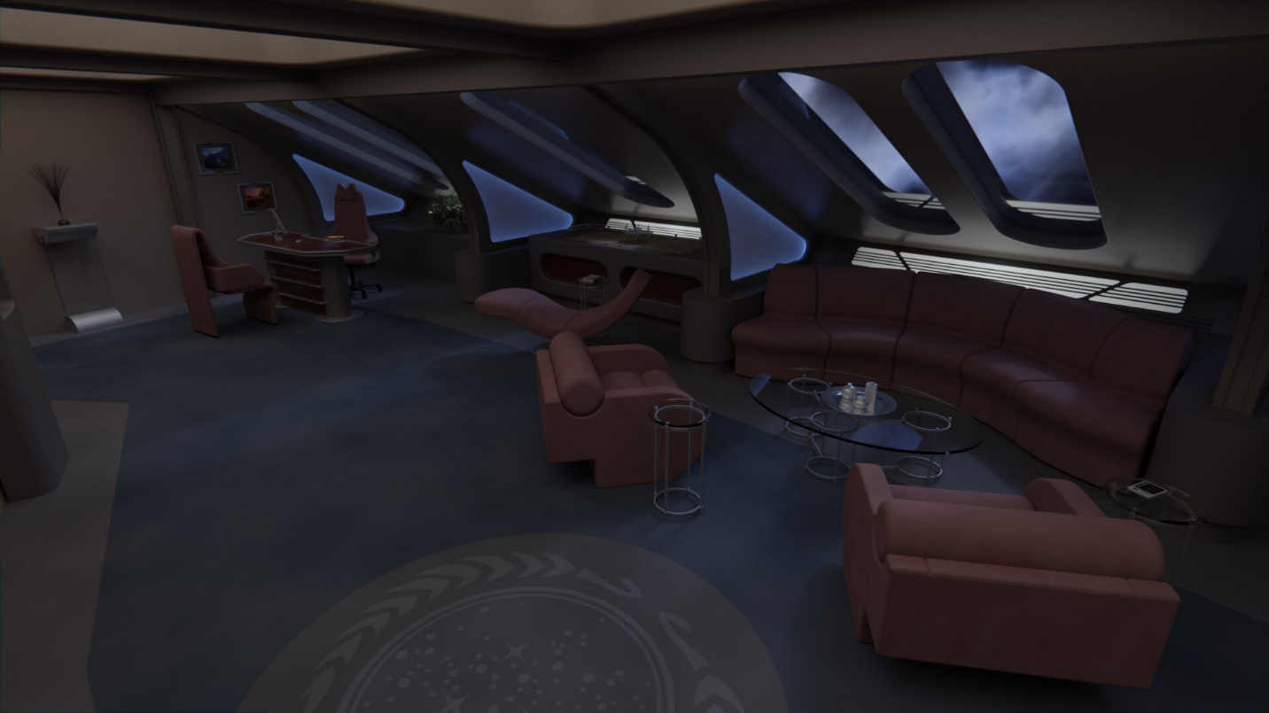Spaceship Transport Shuttle:

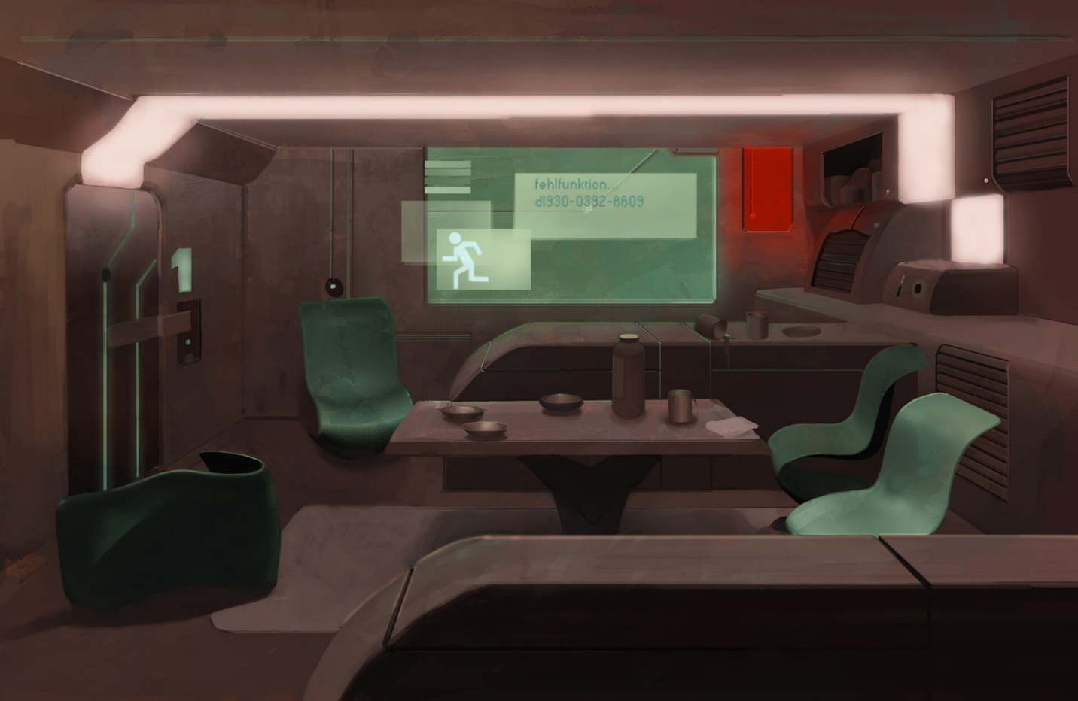

<https://www.artstation.com/artwork/w8qwDg>

<https://www.artstation.com/artwork/mqYz8Y>

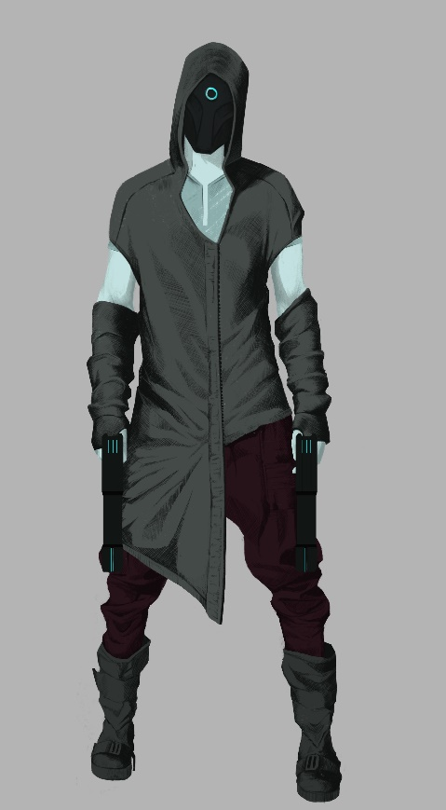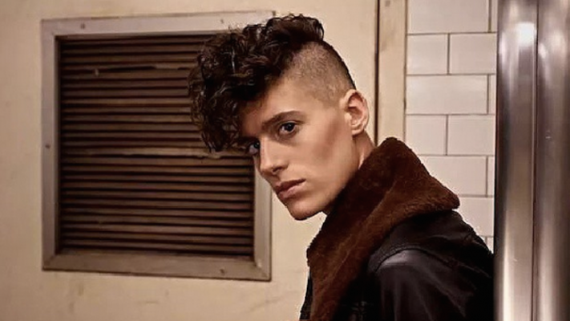Catnip:

[Genderqueer](https://www.artstation.com/artwork/zAOAQq) model Rain Dove

<https://www.artstation.com/artwork/zAOAQq>

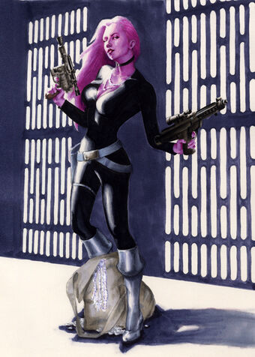

Eun-ji:



Singer Amber Liu

Celin species loosely inspired by Star Wars Zeltron

Goose: like a slightly younger Benicio del Toro

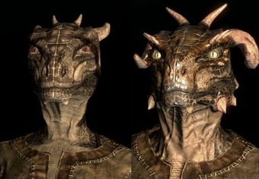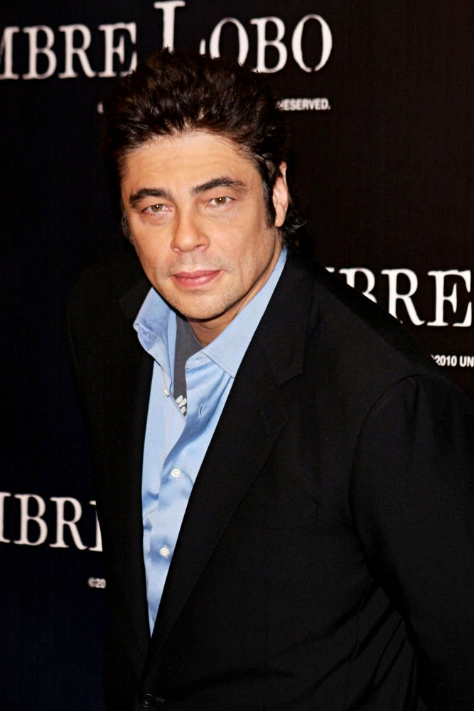

Dara: Kind of like the Argonians of the Elder Scrolls, but with much smaller/vestigial eyes (from living underground), and less humanoid—proportions are more reptilian (longer torso, shorter limbs)

Jayden: Intentionally looks as unassuming as possible. Tries to blend into most environments. Seems apathetic and weak on the outside, but can show the depth of his cold killer instinct when necessary.

<https://www.artstation.com/artwork/v1VKvv>

